Analysis In Algorithm

# In General Analysis Of Algorithm is One of the Important Concept ,

For the Organization , Getting the Output or Build the Solution is Not Important Concept , The More Important is How Effective Your Code is

EX : If u went for the Interview there are 4 people include u , interviewer assign a problem all 4 are solved but in for the Organization they Will Pick One Who Write the code very Effective Way , For This Data Structure & Algorithms are Super Important .

Every Problem Statement has At least 4 Type of Solutions

Like S1 , S2 , S3 , S4 ….

We Will Pick S2 becozz of the proper Metrics compare other 3 , So S2 is the Optimized Solution For the Given Problem

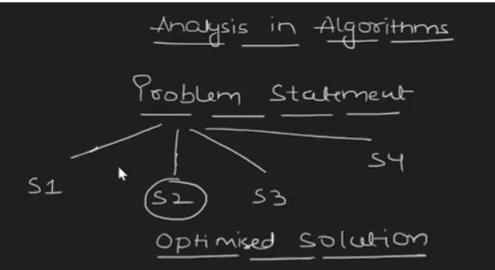

How will We Say This is the Optimized Solution ?

There are Two Types of Factor To Come To the Conclusion :

1. Time Complexity
2. Space Complexity

Time Complexity :

How Much time it takes to Solve my Problem

We need Minimum Amount Of Time To Get the Result .

Space Complexity :

How Much Space(Memory) Our Code takes to Execute the Result .

We need Minimum Space

So we Will Denote Asymptotic Notation To Declare Space & Time complexity, help of these Notion (Metrics) We Evaluate Our Code(Solution) How Optimized .

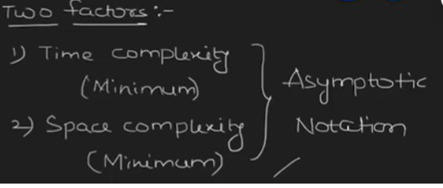

If we Have Two Solution for the Problem with Their own Space & Time Complexity :

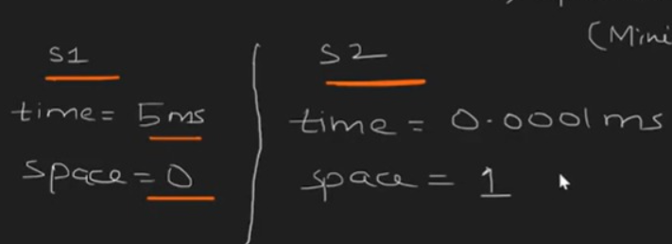

Which One we Choose :

We Will Go with S2 , becozz Tradeoff between Time & Space , People now days have Huge Device with More Spaces but they don’t Have Patience (Time) , So we Will Go With S2

**So In Maximum Time WE will Go For Time Aspect more than Space Aspects**

Time Complexity > Space Complexity

Types Of Analysis

1. Apostiary Analysis
2. Apriori Analysis

Apostiary Analysis: (Relative Analysis)

* Dependent on the Language of Compiler , and type of hardware we are using .
* Exact Answer we Get
* Every Time we Get Different Answer
* Program running fast becozz of hardware efficient.

Apriori Analysis : (Absolute Analysis)

* Independent of language Of Compiler and type of hardware we using , it is completely different to Previous one .
* Approximate Result we Get
* Every Time we Get Same Answer
* Program Running Fast Becozz of Time Complexity is Less(Good Logic).

We Always Use Absolute Analysis(Aprior Analysis)

So Language and Hardware are not so important for efficient , Good Logic Always the Matter .